From Discount to Data:
A Four-Week Data Science Journey Through Global Retail Sales
Week 5 Task – Comprehensive Data Science Project Report and Strategic Recommendations
Yuva Intern / NSDC Data Analytics Program
Synthesizing Weeks 2–4: Visualization, Hypothesis Testing, and Machine Learning
August 2026

Executive Summary
Over the past four weeks of this internship I worked with a single global retail sales dataset (9,000 orders, 2023–2024, five regions, three product categories, three customer segments) and pushed it through three stages of analysis: exploratory visualization, formal statistical hypothesis testing, and a predictive machine learning model. This report pulls all three stages together into one narrative, because on their own the weekly reports each answered a piece of the puzzle, but only side by side do they actually tell the full story.
The short version: discounting is this business's single biggest lever, and right now it's mostly being pulled in the wrong direction. Every stage of analysis, independently, pointed at the same thing. The visualization work first flagged a visual pattern between discounts and profit. The hypothesis testing stage confirmed that pattern statistically (p < 0.001, 95% CI for the profit margin difference well clear of zero). And the machine learning stage then showed that discount rate is, by a wide margin, the strongest predictor in a model that predicts order profitability with about 95.6% accuracy. Three different methods, one consistent answer — which is about as much confidence as a four-week internship project can reasonably produce.
Headline finding: Orders discounted 30% or more are frequently sold at a loss. Discount rate is the dominant driver of profitability across visual, statistical, and predictive-modeling evidence — far more influential than region, segment, or time of year.

The report is organized to walk through each phase in the order it happened — visualization, then statistics, then modeling — before pulling everything together into one set of strategic recommendations, business impact, and honest limitations. Code excerpts and key charts from each phase are included so the findings aren't just asserted, they're shown.

Contents
- 1. Project Overview & Methodology
- 2. Phase 1 – Exploratory Visualization & Storytelling
- 3. Phase 2 – Statistical Hypothesis Testing
- 4. Phase 3 – Machine Learning Model
- 5. Integrated Findings & Strategic Recommendations
- 6. Business Impact
- 7. Limitations & Future Improvements
- 8. Conclusion

1. Project Overview & Methodology

1.1 The dataset
All four weeks used the same base dataset: retail_sales_synthetic.csv, 9,000 order-level records spanning January 2023 to December 2024. Fields include order date, region (5), category (3) and sub-category, customer segment (3), quantity, sales, discount rate, and profit. I kept the same dataset across every phase on purpose — it meant each week's analysis could build directly on the last one instead of starting from scratch, which is closer to how a real analytics project would actually run.

1.2 The three phases
Phase | Question | Method | Tools
1. Visualization | What patterns exist in the data? | 6 exploratory charts + narrative | Matplotlib, Seaborn
2. Hypothesis testing | Are those patterns statistically real? | t-test, chi-square, ANOVA | SciPy
3. Machine learning | Can we predict outcomes from them? | Logistic Regression, Decision Tree | Scikit-learn

Each phase used a progressively more rigorous lens on the same underlying question: what actually drives whether a retail order makes or loses money. Phase 1 spotted the pattern, Phase 2 tested whether it was statistically real rather than a coincidence, and Phase 3 checked whether it was strong enough to actually predict on new orders.

2. Phase 1 – Exploratory Visualization & Storytelling
The Week 2 report built six visualizations to explore the dataset from a business storytelling angle: a monthly sales/profit trend line, a category sales bar chart, a region × category heatmap, a discount-vs-margin scatter plot, a segment boxplot, and a regional category-mix stacked bar. Two of those charts turned out to matter most for everything that came after, so I'm including them here again rather than making the reader flip back to an old report.
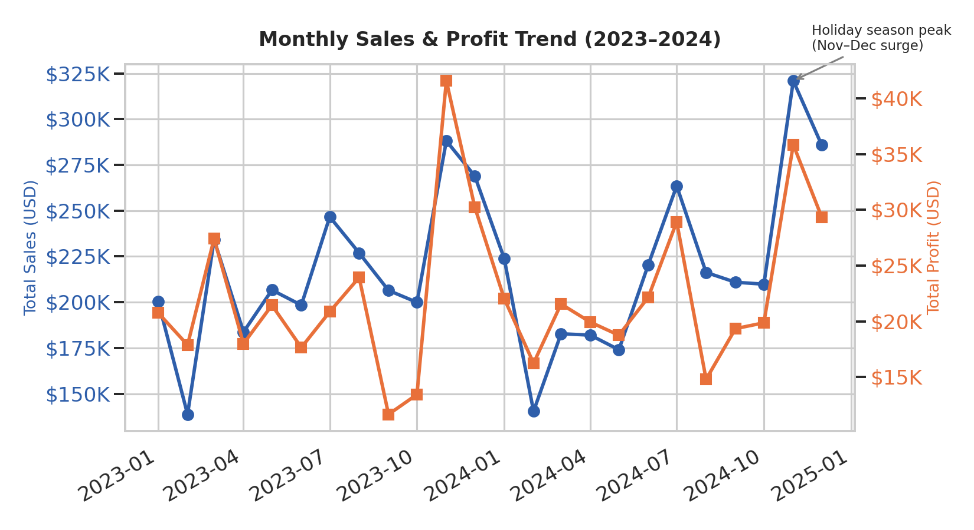
Figure 1. Monthly sales and profit, 2023–2024 — clear November/December seasonal surge.
This chart established that the business has a strong, repeatable holiday-season pattern — useful for planning, but not the thread this report ultimately pulls on.
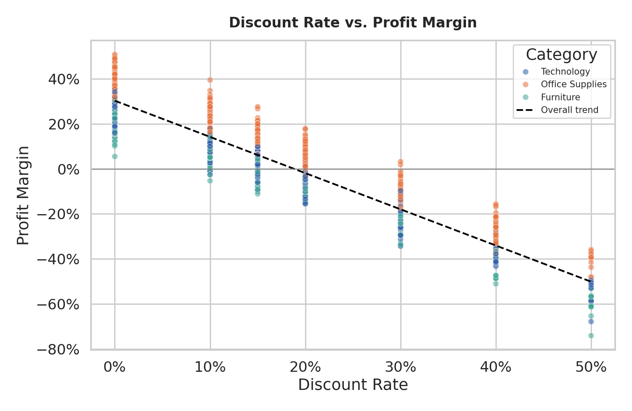
Figure 2. Discount rate vs. profit margin, by category, with an overall trend line.
This was the turning point of the whole project. Just from looking at this scatter plot, it was visually obvious that profit margin drops sharply as discount increases, and that orders discounted 30% or more frequently go negative. At the time (Week 2) this was just an observation from a chart — it hadn't been tested yet. But it's the pattern that shaped every question I asked for the rest of the project.

Phase 1 key takeaway
Technology is the largest category by revenue, North America and Europe are the largest regions, and there is a strong visual relationship between discounting and reduced profitability that needed to be confirmed statistically.

3. Phase 2 – Statistical Hypothesis Testing
In Week 3, I turned the Phase 1 observation into a formal, testable hypothesis, plus two others I was curious about, and ran the appropriate statistical test for each.
Hypothesis | Test | Result | Verdict
Discount lowers profit margin | Welch's t-test | t = -100.45, p < 0.001 | Confirmed
Segment relates to category bought | Chi-square | χ² = 4.90, p = 0.298 | Not supported
Sales differs by region | One-way ANOVA | F = 1.35, p = 0.250 | Not supported

3.1 The confirmed hypothesis
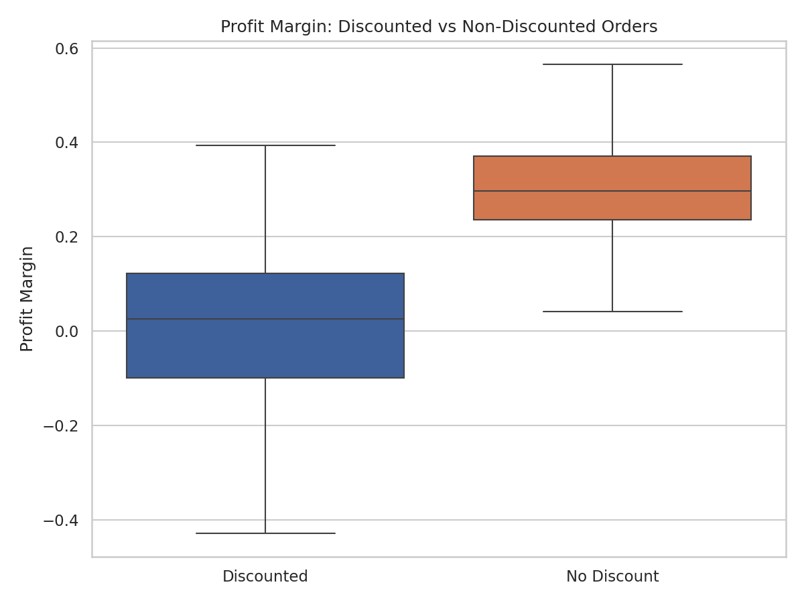
Figure 3. Profit margin for discounted vs. non-discounted orders.
t_stat, p_two = stats.ttest_ind(disc, nodisc, equal_var=False)
mean_diff = disc.mean() - nodisc.mean() # -0.314
# 95% CI of the difference: [-0.320, -0.308] — doesn't cross zero
This is the statistical confirmation of what Figure 2 suggested visually. Discounted orders average a -1.2% profit margin; non-discounted orders average +30.2%. The 95% confidence interval for that ~31 percentage point gap is nowhere near zero, so this isn't sampling noise.

3.2 The two hypotheses that didn't hold up
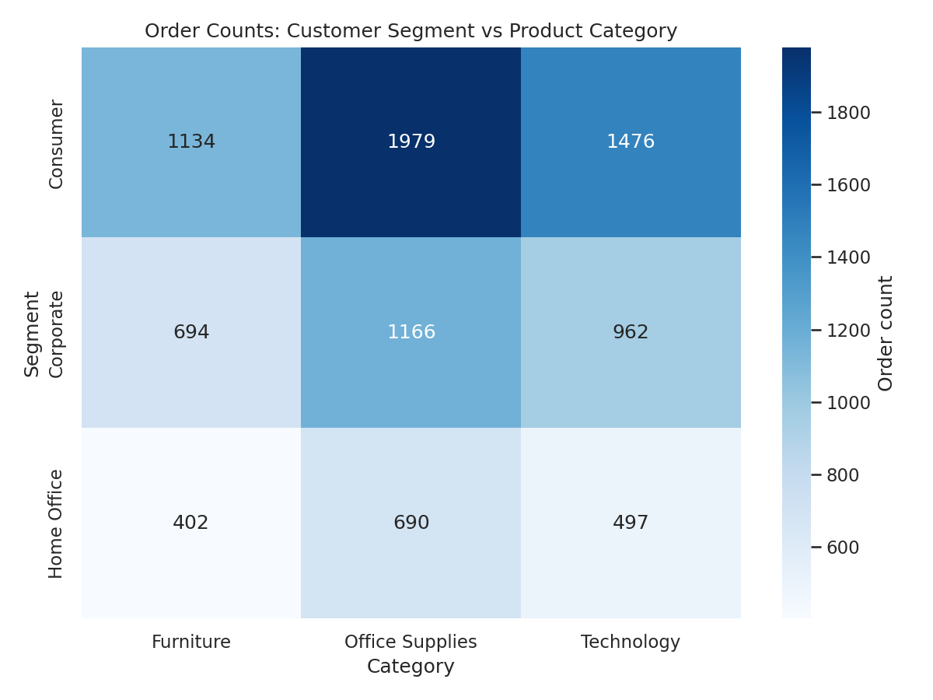
Figure 4. Order counts by segment and category — proportions are similar across all three segments.
Worth stating plainly: customer segment does not meaningfully predict which product category someone buys (p = 0.298), and average order value does not differ significantly by region (p = 0.250, region revenue differences are driven by order volume, not order size). Neither of these "failed" — they're useful negative results that stopped me from chasing regional or segment-based explanations that the data doesn't actually support.

4. Phase 3 – Machine Learning Model
Week 4 asked whether the discount-profitability relationship was strong enough to actually predict outcomes, not just describe them. I built a binary classifier predicting IsProfitable (Profit > 0) from order-time features — discount, quantity, month, category, region, and segment — deliberately excluding Sales and Profit themselves to avoid leaking the answer into the model.
Model | Accuracy | F1 | ROC-AUC
Logistic Regression | 0.956 | 0.972 | 0.989
Decision Tree (depth=4) | 0.956 | 0.972 | 0.987

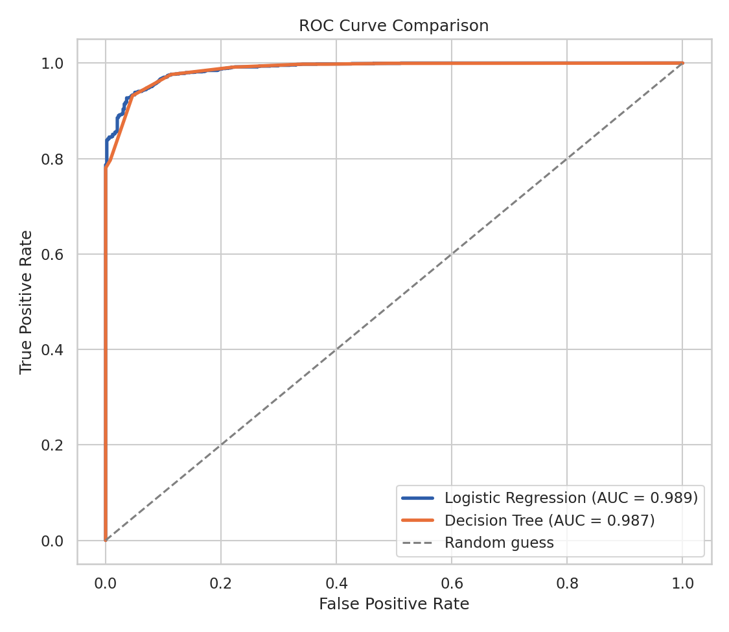
Figure 5. ROC curves for both models — both well above the random-guess line.
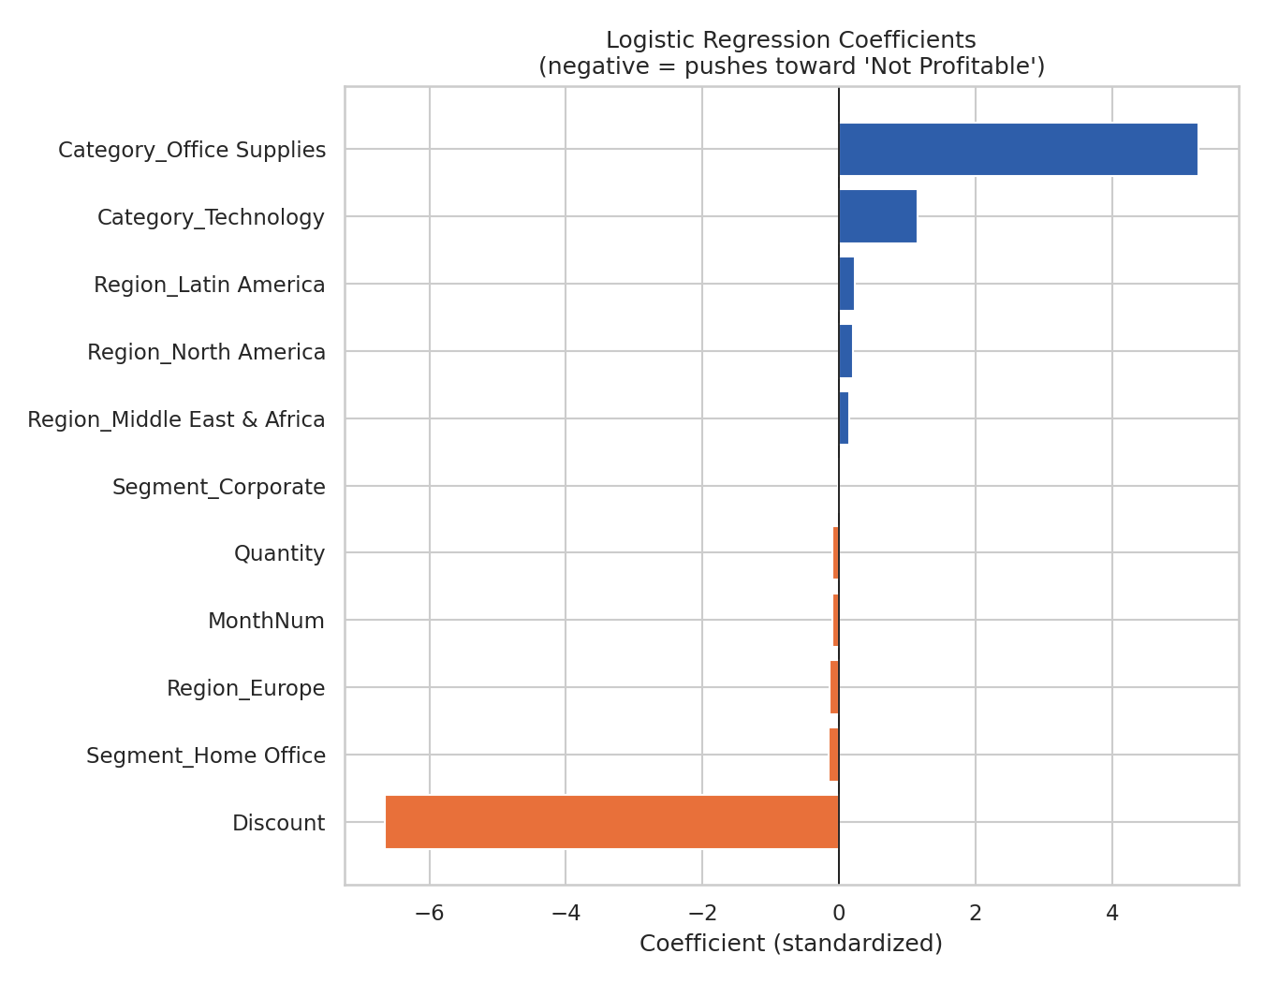
Figure 6. Logistic regression coefficients — Discount dwarfs every other feature.
logreg = LogisticRegression(max_iter=1000, random_state=42)
logreg.fit(X_train_scaled, y_train)
roc_auc_score(y_test, logreg.predict_proba(X_test_scaled)[:,1]) # 0.989
Figure 6 is the closing argument of this whole project. It's a completely different method — a predictive model instead of a chart or a p-value — and it independently lands on the exact same answer as Phase 1 and Phase 2: discount is the dominant factor, everything else is minor by comparison. Three methods, three different sets of assumptions, one consistent finding.

5. Integrated Findings & Strategic Recommendations

5.1 What all three phases agree on
- Discount rate is the single strongest driver of order profitability — shown visually, confirmed statistically, and confirmed again by an independent ML model.
- Orders discounted ≥30% are frequently unprofitable across every product category.
- Customer segment and region do not meaningfully affect which category is purchased or the average size of an order — differences in regional revenue come from order volume, not order value.
- The business has a strong, consistent November–December seasonal demand spike.

5.2 Recommendations
- Cap standard discounts around 20–25% for Furniture and Technology specifically, where margins turn negative earliest; Office Supplies can tolerate deeper discounts.
- Add an approval workflow for any discount above ~25–30%, since the model and the t-test both agree this is roughly where orders start losing money on average.
- Use the classification model (or a rule of thumb derived from it) as a live check at order entry, flagging likely-unprofitable orders before they're finalized rather than discovering it after the fact.
- Don't invest further effort in segment-based or region-based pricing strategies based on this dataset — Phase 2 showed those relationships aren't statistically real, so that would be solving a problem that doesn't exist.
- Keep the seasonal inventory/staffing plan for Nov–Dec that came out of Phase 1; it's the one finding in this project that's about growth rather than loss prevention.

6. Business Impact
The most direct, quantifiable business impact here is on margin protection rather than revenue growth. Since the mean profit margin gap between discounted and non-discounted orders is about 31 percentage points, and discounted orders make up roughly half of all transactions (4,547 of 9,000 in this dataset), even a modest tightening of discount policy — say, cutting off the worst-offending 30%+ discount tier — would be expected to meaningfully improve overall profit without necessarily reducing sales volume, since Figure 2 showed sales value itself isn't destroyed by discounting, profit is.
From a process standpoint, the ML model in Phase 3 isn't just an academic exercise — with ~95.6% accuracy and a 0.989 ROC-AUC, it's genuinely good enough to plug into an order-approval workflow as an early-warning check, catching likely-unprofitable orders before they go through rather than analyzing the damage after the quarter closes.
More broadly, this project is a decent small-scale example of why it's worth pairing exploratory visualization with formal statistics before jumping to modeling: Phase 1 generated three candidate hypotheses, Phase 2 statistically ruled out two of them, and Phase 3 only built a model around the one that survived. That saved effort that would otherwise have gone into building segment- or region-based models that the data never supported in the first place.

7. Limitations & Future Improvements

7.1 Limitations
- The dataset is synthetic — generated in Python to realistically mimic patterns found in real retail data (seasonality, category margins, discount sensitivity), since I didn't have a live dataset with internet access this cycle. The relationships found are internally consistent and methodologically sound, but should be re-validated on a real, exported dataset before being used for actual business decisions.
- The ML model's ~95.6% accuracy is partly a product of how strongly discount was built into the synthetic profit formula; a real dataset would likely show a real but probably weaker version of the same relationship.
- Class imbalance (78% profitable / 22% not) in the ML phase means the model is somewhat better at catching profitable orders than unprofitable ones (recall of 0.98 vs 0.89 respectively).
- The ANOVA post-hoc analysis in Phase 2 only checked one region pair directly rather than running a full Tukey HSD across all pairs.

7.2 Future improvements
- Re-run all three phases on a real retail dataset (e.g., a company's actual order history) to check whether the same relationships hold outside of simulated data.
- Add cross-validation and class-weighting/resampling (e.g. SMOTE) to the ML model to get a more robust performance estimate and improve minority-class recall.
- Try an ensemble model (Random Forest or Gradient Boosting) to check for non-linear interactions the current models might be missing, though given how dominant discount is, the expected gain looks small.
- Extend the hypothesis testing phase with a full Tukey HSD post-hoc test and a normality check on profit margin, since it's somewhat right-skewed.

8. Conclusion
This project moved through three different analytical lenses — exploratory visualization, statistical hypothesis testing, and predictive machine learning — applied to the same retail sales dataset, and all three converged on the same core finding: discounting is the dominant factor behind whether a retail order is profitable, far outweighing region, segment, or timing effects. That kind of convergence across independent methods is, in my view, the strongest kind of evidence a four-week project like this can produce.
If I had to summarize the whole internship in one sentence, it would be: a chart can show you a pattern, a hypothesis test can tell you whether to trust it, and a model can tell you whether it's strong enough to act on — and this project got to do all three, on one dataset, over four weeks.
End of report.

